**Assignment #4 - SQL Jumpsuit**

Given our technical ups and downs this week, we're going to keep our assignment pretty simple. Your task is to create a small database with a few rows and at least four columns, then create a page that lists out the contents of that database in a <table>. So it's basically a repeat of last assignment, but with a database instead of an array. This is also a chance to show me your ability to use arrays in a page that is not a copy of our in-class work: be creative!

Given that this assignment is basically an adaptation of previous work, you should finish fairly quickly. If you do, take a few minutes and see if you can also make the table headers "sortable" — i.e., by clicking on a link in the header, the page should reload with the table sorted by that column. Doing this with *ORDER BY* in the database is not hard, but be sure to do it in a secure way!

Scp –r . itc240.no-ip.org:~

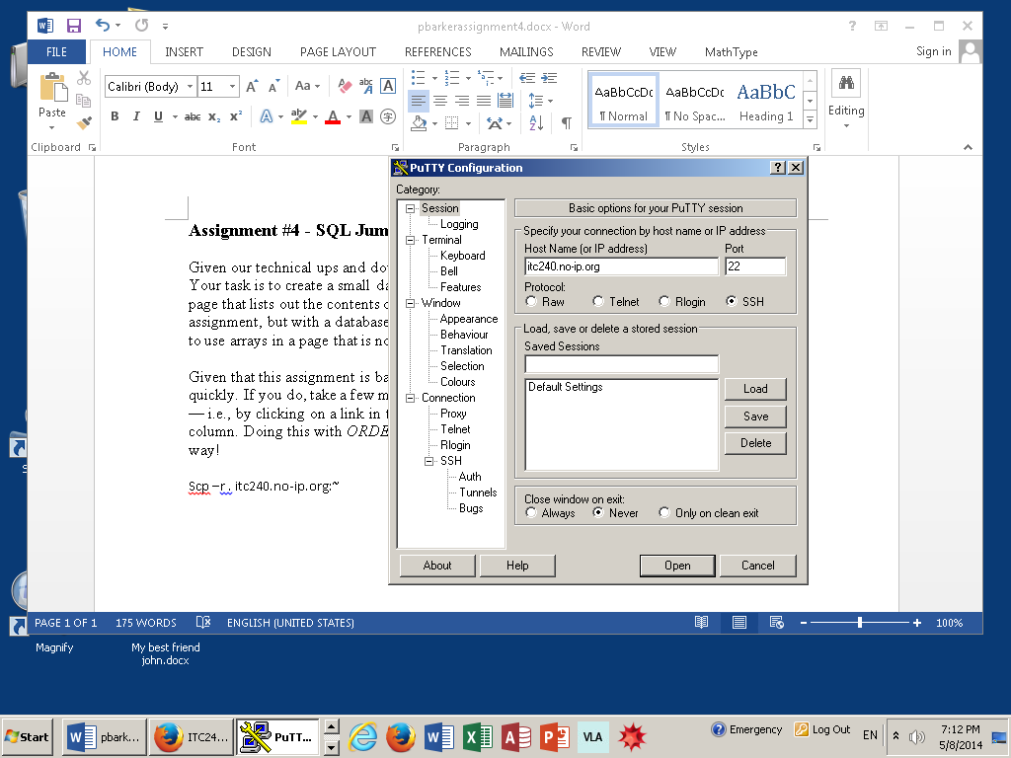

itc240.no-ip.org

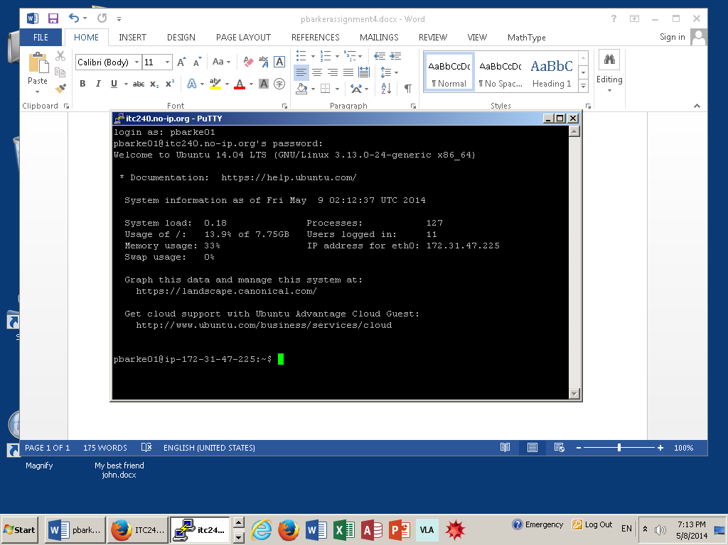

There will be no parameters.

Do not use the unsafe way!!

type

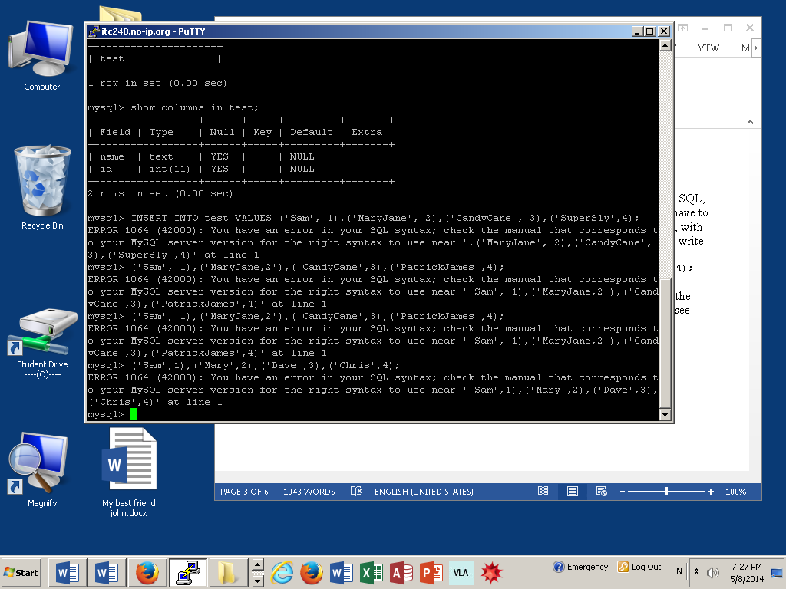

<?php

//params: server, username, password, database

//you want to keep things off your source code…so do not put them here, create ***passwords.php***

$mysql = new mysqlli(“localhost”, “pbarke01”,”$mysql”,”pbarke01”);

In the ***.gitignore*** file use this command, which keeps this file out of all locations

**/passwords.php

`````````````````````````````

For the assignment ------ insert images ***via img scr***

?>

<table>

<?php

foreach ($result as $row) {

?>

<tr>

<td> <? = $row[“type”] ?> </td>

<td> <? = $row[“legs”] ?> </td>

</tr>

<?php

}

?>

</table>

***Make the table header sortable (*query statement and if statement*) pick a select statement***

***Pick a parameter….$sort***

**$sort = $_REQUEST[”sort”];**

**if ($sort == “type”) {**

**$query = ‘SELECT * FROM animals ORDER BY type; ’ ;**

**}**

**$mysql->query($query);**

**May 13….before class**

mysql -D your_username -p

CREATE TABLE presidents (name TEXT, party TEXT, religion TEXT, state TEXT, inauguration DATE);

mysql> SHOW TABLES;

mysql> SHOW COLUMNS IN presidents;

mysql> INSERT INTO presidents VALUES

('Washington', ‘Whig’, ‘Episcopalian’, ‘West Virginia’ 01/04/1789),

('Jackson', ‘Democrat’, ‘Presbyterian’, ‘Tennessee’, 01/07/1829),

('Lincoln', ‘Republican’, ‘Baptists’, ‘Illinois’, 01/21/1860),

('Obama', ‘Democrat’, ‘Catholic’, ‘Illinois’, 01/14/2009)

(‘Clinton’, ‘Democrat’, ‘Baptists’, ‘Arkansas’, 01/15/1993)

(‘Truman’, ‘Democrat’, ‘Baptists’, ‘Missouri’, 01/21/1945);

msyql> SELECT * FROM presidents;

msyql> SELECT name FROM presidents;

mysql> SELECT * FROM presidents WHERE Date > 1955;

mysql> SELECT * FROM presidents WHERE name = 'Washington';

1